Maths on a Page
Intent
At Thorpe Primary School we want to create confident, skilful mathematicians who have a life-long love of mathematics and can expertly apply their knowledge and understanding.
Implementation
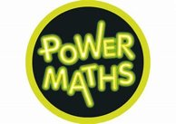
At Thorpe Primary School we use Power Maths to help develop a deeper understanding of mathematics through: fun practical activities, exploration, discussion, problem solving and reasoning.
- Power Maths lessons daily.
- Year group team work together to adapt the learning journey to meet the needs of the children including additional strengthen and deepening activities (including Blue book lessons). One member of the year group takes overall responsibility.
- Number bonds and times tables weekly.
- KS2 weekly arithmetic test and feedback session.
- Fingertip facts promoted through homework and regular low-stake quizzes.
- Mental and oral starters including revising previous content and use of Flashback 4 resources.
We are currently developing our use of:
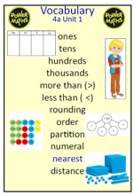
Vocabulary: This will be explicitly shared, referred to and modelled within the unit of work. Children will be actively encouraged to use the vocabulary in verbal and written form. Vocabulary will also be displayed on the working wall.
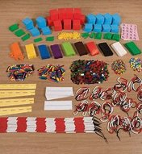
CPA: Where children are exposed to a new concept, concrete materials will be used. Children will be encouraged to transition through using concrete manipulatives, pictorial representations to the abstract. The suggestions within the Power Maths teachers’ guide for which manipulatives are essential for children’s learning will be followed. There will be no stigma attached to using manipulatives.
We also use the following resources to support our teaching of maths (particularly when creating strengthen/deepen activities): Classroom Secrets, White Rose Maths, Twinkl mastery materials, Everyday reasoning and problem solving, Can you Convince Me?, I See Reasoning and ‘Dip and Pick’ Reasoning Materials.
Impact
We continue to judge this by the following criteria:
- Children are positive and confident about maths and how it is taught.
- Teachers consider the approach taken in maths to be effective in meeting the needs of their pupils.
- Parents feel well-informed about how their children learn maths and how they are developing as a learner.
- Attainment and progress continues to improve in line or above national average with the disadvantaged children attaining in line with their peers.

