Dear Parents and Carers,

What an exciting week it has been at Thorpe - our World Cup Week has been great fun! From creative flag-making to friendly football matches, it’s been fantastic to see pupils and staff getting involved and sharing in the fun. On Friday, pupils learned about different countries participating in the World Cup – a great opportunity to learn more about our diverse world. Of course, we can’t forget the excitement around the England vs. Croatia match on Wednesday, which ended with a thrilling 4 – 2 result! It’s been wonderful to see so many children enthusiastic about the game and sharing their thoughts the next day. However, we’d like to gently remind families that, while these matches are memorable, it’s important for pupils to get enough rest and sleep. Children are still expected to come to school ready to learn and complete their work the following day.

The weather is becoming warmer, so please ensure your child is prepared for this (applying sunscreen in the morning, bringing in hats and water bottles). Please be advised that pupils are not permitted to bring in hand fans as these are too much of a distraction from learning. Classes are well ventilated and there is not a need for them.

Sports Day Is Coming Up Next Week

We encourage everyone to join us next week for some friendly competition, encouragement, and celebration of our pupils’ efforts. Fingers crossed that the good weather continues. Please see the details on the poster below.

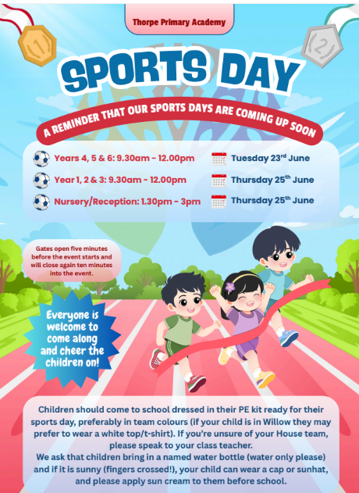
Attendance

Please see below the class-by-class attendance break down for the week 08.06.26 to 12.06.26 (last week). Well done to 6 Ibbotson for the best attendance that week.

Registration Form | Present R/C: Marks (%)
1 Grey | 98.0%
1 Murphy | 95.3%
2 Blake | 94.3%
2 Rosen | 89.3%
3 Cowell | 92.5%
3 Rowling | 98.6%
4 Lewis | 96.7%
4 Morpurgo | 97.5%
5 Dahl | 93.2%
5 Strong | 96.5%
5 Walliams | 93.0%
6 Blackman | 90.7%
6 Ibbotson | 99.3%
Nursery 1 | 90.6%
Nursery 2 | 89.2%
R Carle | 95.8%
R Donaldson | 93.3%

Learning Spotlight

Year 2 had a wonderful trip to Hunstanton, where they enjoyed an exciting day of learning about sea life and coastal habitats. As part of their hands-on learning experience, the children explored the beach, feeling the textures of the sand and seawater, which helped bring their learning to life.
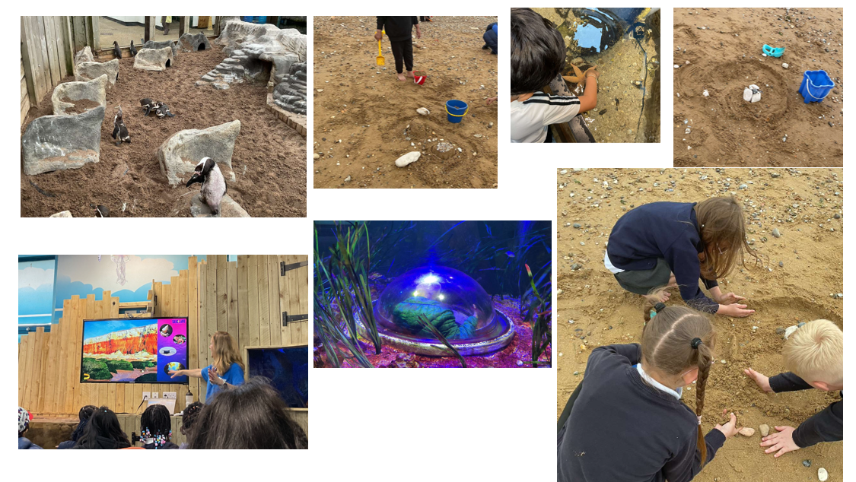

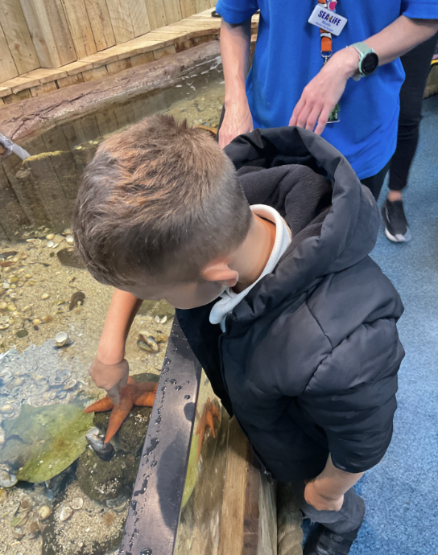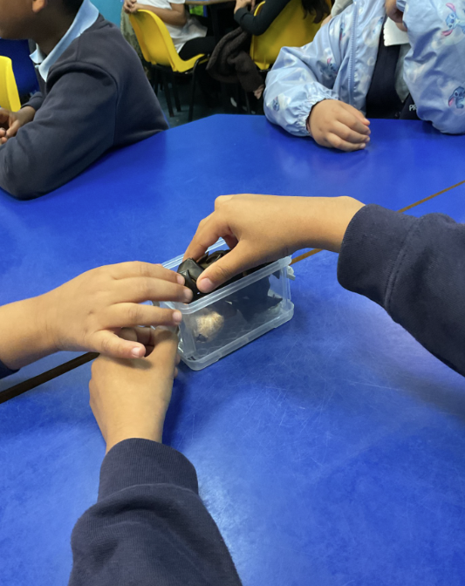

Year 4 have been exploring magnetism in science and how adding multiple values increases the magnetism. In computing, they have created ‘loops’ to program dinosaurs to change colour, move in different directions and rotate. During history they researched various historical buildings in and around Peterborough. They had the opportunity to research someone linked to Burghley House and created superb fact files about this.

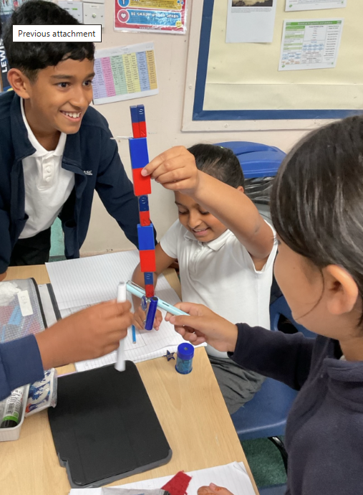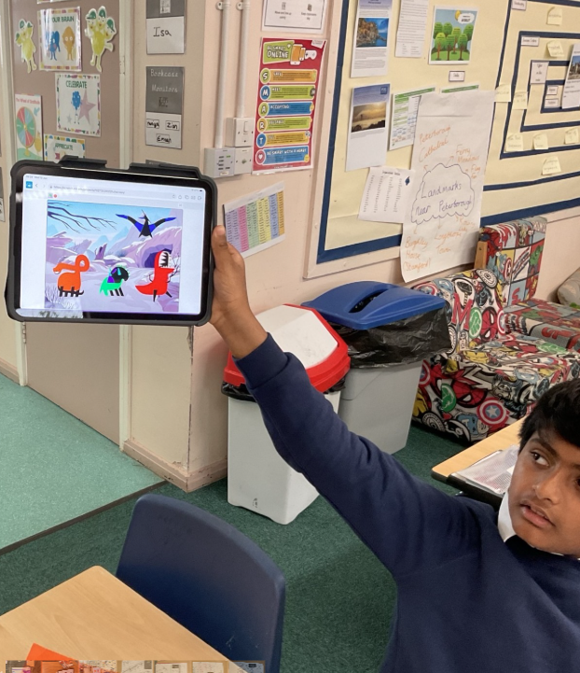

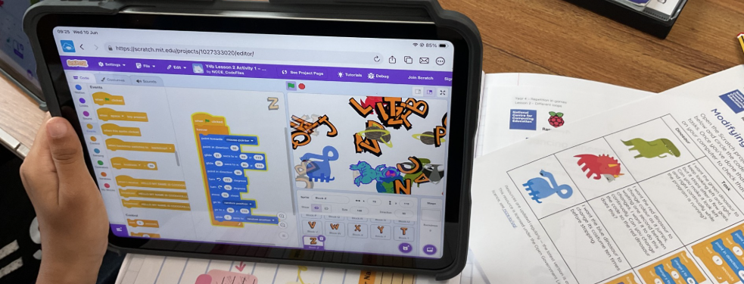
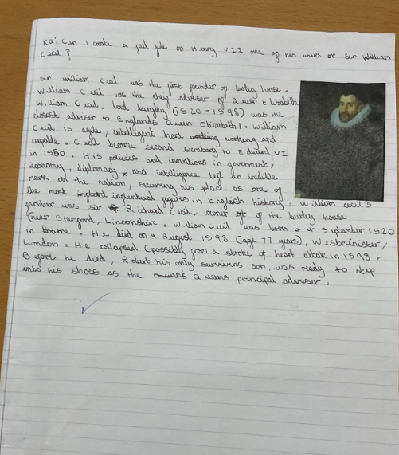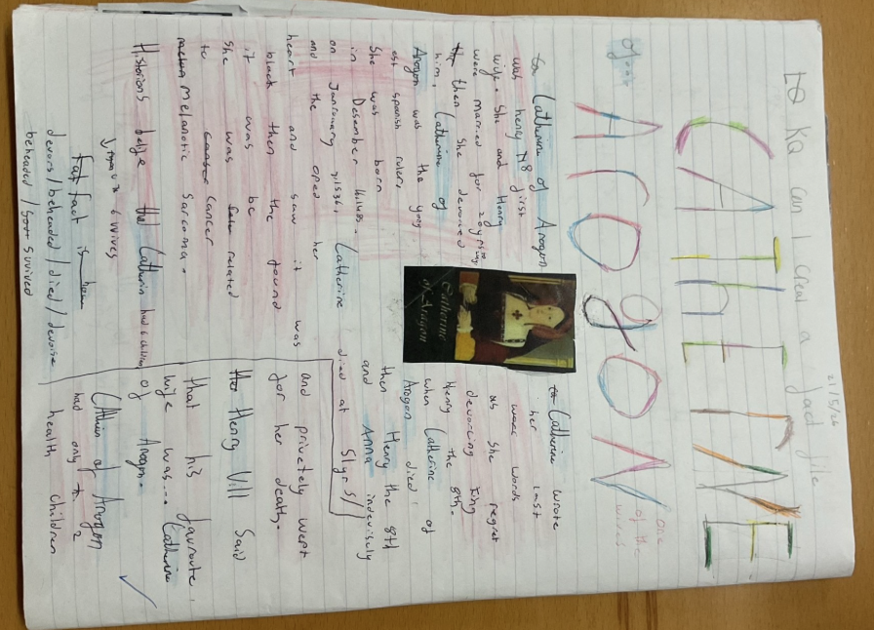

Paul Bristow, Mayor of Peterborough and Cambridgeshire, also visited year 4 this week where the children interviewed him in preparation for their next piece of writing. Paul was very complimentary about the children’s conduct and line of questioning.

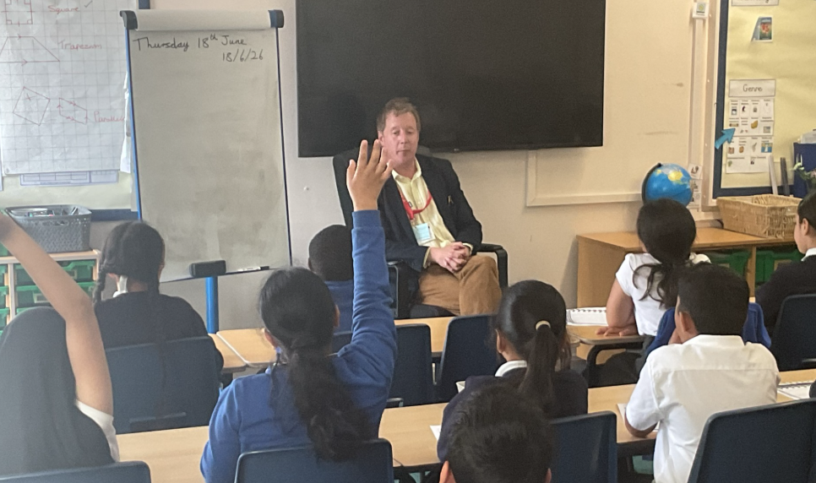

Reminders

School Disco

We are very excited to invite children from Reception to Year 6, to our end of term disco! Y6 pupils have also been invited to stay on after the disco to join in a pizza party. The disco will take place on Tuesday 14th July and there will be 2 separate timings for Reception/Key
Stage 1 and Key Stage 2. Please see below timings:

- Reception, Year 1 & Year 2 – 17:00 - 17:45
- Year 3, Year 4, Year 5 & Year 6 – 18:00 - 18:45
- Year 6 Pizza Party – 18:45 - 19:15

The disco includes a snack and a drink. If you would like your child to attend, please make the
payment of £3 on Arbor and give consent. If you would like your child to attend the pizza party too, this is set up as a separate payment on Arbor and is an additional £3. Payment will not be accepted on the day. Please Note:
- We will be unable to take any bookings after Monday 6th July
- Parents are not able to stay during the disco
- All children need to be dropped off at the KS2 gate and collected from the car park
- Key Stage 1 & Key Stage 2 disco are separate and cannot be mixed
- We will contact you to collect your child if behaviour is not suitable

Should you require any further information or have any question, please do not hesitate to speak to the school office.

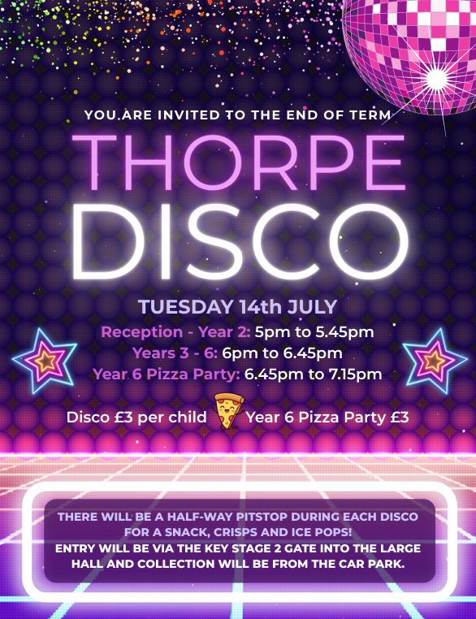

Key Dates Coming Up:

Date | Event
Tuesday 23rd June | 09.20 – 12.15: Years 4, 5 and 6 Sports Day.
Wednesday 24th June – Friday 26th June | Year 6 residential trip to Boughton Woods.
Thursday 25th June | - – 12.15: Years 1, 2 and 3 Sports Day.  13.30 – 15.00: Nursery & Reception Sports Day.
Thursday 25th June | 2.50pm: Year 4 class assembly.
Monday 29th June – Tuesday 30th June | Year 5 Fenland Adventure camping experience.
Wednesday 1st July | Year 6 transition day to Jack Hunt.  Meet your new class teacher day (Move up day).  Reception ‘stay and plays’.
Thursday 2nd July | Peterborough Jewish community visit.
Wednesday 8th July | End of year reports to be sent home.
Thursday 9th July | 2.50pm: Reception class assembly.
Thursday 9th July | Parents’ Open Evening.
Tuesday 14th July | School disco  - Reception, Year 1 and Year 2: 17.00 – 17.45  - Year 3 - 6: 18.00 – 18.45  - Year 6 stay for pizza: 18.45 – 19.15
Wednesday 15th July | 14.00: Year 6 End of Year Parent Showcase.
Friday 17th July | School finishes at 13.00 for all children in nursery – Year 5 (Year 6 finish at 13.15).
Friday 17th July | 13.15: Year 6 Parent & Teacher ‘Clap Out’.

Class Assemblies Summer Term

Please see the timetable below for the Summer Term. They start at 2.50pm and finish at 3.10pm on the designated day (always a Thursday). If you can make it, please come along.

Date | Classes
Thursday 25th June | Year 4
Thursday 9th July | Reception

Parent Shout Outs

If your child’s teacher or another member of staff has gone above and beyond, I would love to hear from you. Please click here: https://forms.office.com/e/6r5w1yxP8F
Have a wonderful weekend and see you on Monday.

Mr J Parkhouse
Headteacher

