Dear Parents and Carers,

As we wrap up another busy week at school, I wanted to take a moment to celebrate the incredible achievements of our pupils. This week, year 1 completed their Phonics Screen Check and year 4 their completed their Multiplication Check. In addition to this, all children completed their end of year tests. Every child gave their best effort, approaching the tests with a positive attitude. It has been truly inspiring to see their progress and confidence grow over the past term. I would also like to extend a heartfelt thank you to our dedicated staff, who have supported and encouraged the pupils every step of the way.

Attendance

Please see below the class-by-class attendance break down for the week 01.06.26 to 05.06.26 (last week). Well done to 4 Lewis for the best attendance that week.

Registration Form | Present R/C: Marks (%)
1 Grey | 95.0%
1 Murphy | 95.0%
2 Blake | 97.0%
2 Rosen | 86.0%
3 Cowell | 94.6%
3 Rowling | 94.6%
4 Lewis | 97.7%
4 Morpurgo | 93.8%
5 Dahl | 95.0%
5 Strong | 97.4%
5 Walliams | 92.1%
6 Blackman | 93.0%
6 Ibbotson | 92.0%
Nursery | 87.7%
Nursery | 81.1%
R Carle | 94.6%
R Donaldson | 86.7%

World Cup Week (Next Week)

In celebration of the upcoming World Cup, we are putting on a special World Cup Week. There will be various events in school related to sports and football, culminating in a non-uniform day on Friday 19th June where children can dress up in the clothing, colours or football kit of the country they will be supporting in this year’s competition.



School Disco

We are very excited to invite children from Reception to Year 6, to our end of term disco! Y6 pupils have also been invited to stay on after the disco to join in a pizza party. The disco will take place on Tuesday 14th July and there will be 2 separate timings for Reception/Key
Stage 1 and Key Stage 2. Please see below timings:

- Reception, Year 1 & Year 2 – 17:00 - 17:45
- Year 3, Year 4, Year 5 & Year 6 – 18:00 - 18:45
- Year 6 Pizza Party – 18:45 - 19:15

The disco includes a snack and a drink. If you would like your child to attend, please make the
payment of £3 on Arbor and give consent. If you would like your child to attend the pizza party too, this is set up as a separate payment on Arbor and is an additional £3.

Payment will not be accepted on the day.

Please Note:
- We will be unable to take any bookings after Monday 6th July
- Parents are not able to stay during the disco
- All children need to be dropped off at the KS2 gate and collected from the car park
- Key Stage 1 & Key Stage 2 disco are separate and cannot be mixed
- We will contact you to collect your child if behaviour is not suitable

Should you require any further information or have any question, please do not hesitate to speak to the school office.


Learning Spotlight

In year 3, children have been roleplaying the traditional tale, 'George and the Dragon'. In art, they will then be using these photos to create a mixed media montage including a sketch of the dragon.

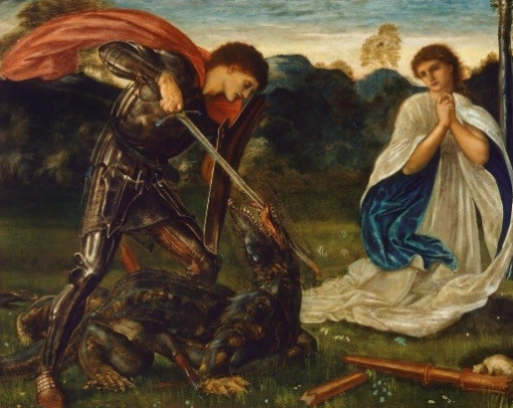
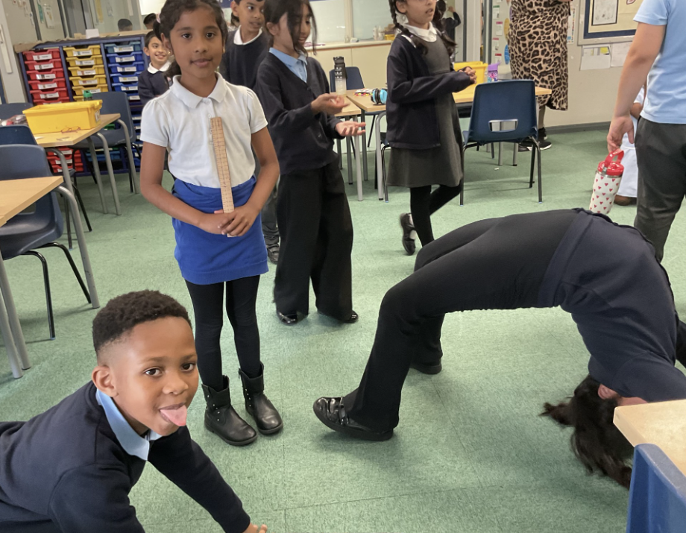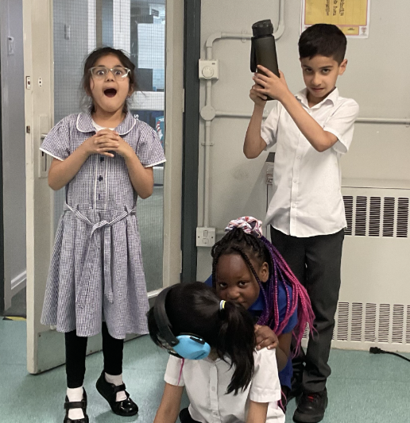

In Nursery, the children made some gingerbread men for their topic story ‘The Gingerbread Man’. They also did some sewing and made a gingerbread man.

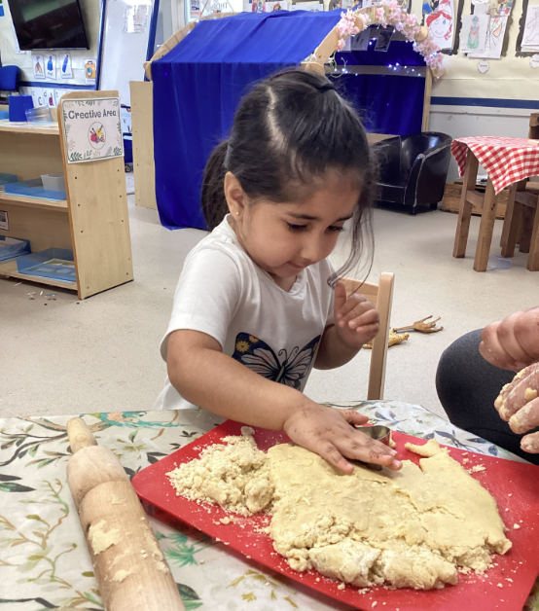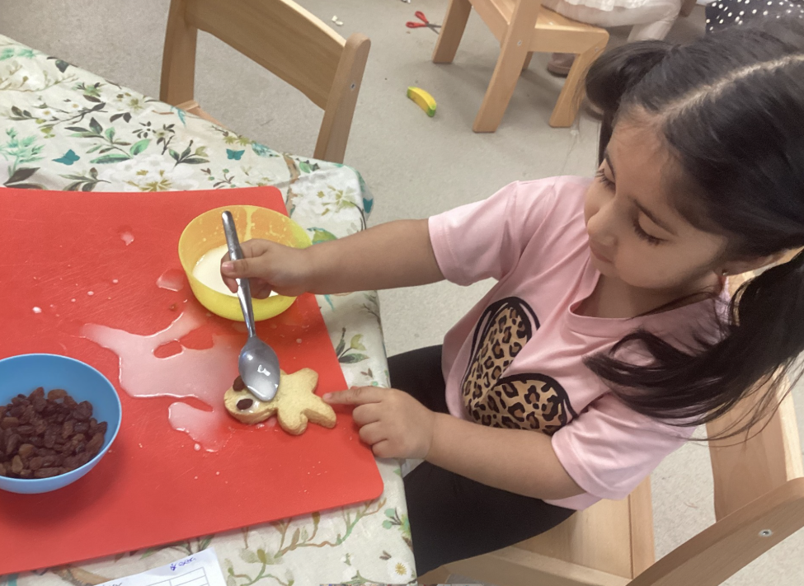
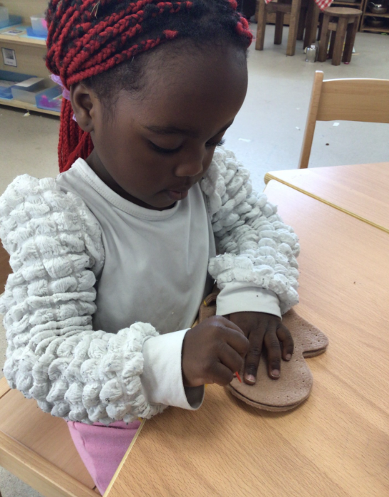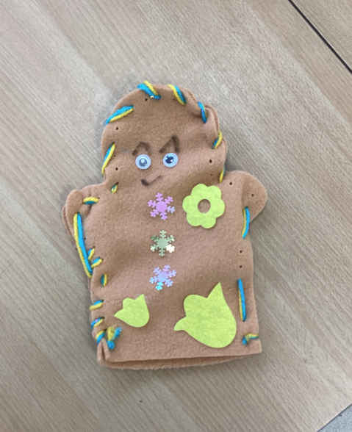
Lunch Survey for Parents/Carers
We are reviewing our school lunch provision and would really value your feedback. Please can you complete this short questionnaire to help us review our service and menus for next year.



Reminders

Sports Days
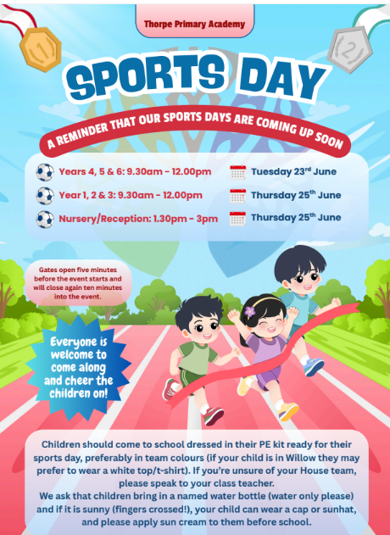
Key Dates Coming Up:

Date | Event
Monday 15th June – Friday 19th June | ‘Eat Like A Footballer’ week (World Cup week).
Monday 15th June | 5pm: New (September 2026 start) reception parents induction evening.
Wednesday 17th June | 3 C swimming session begin.
Thursday 18th June | 2.50pm: Year 5 Strong & Dahl class assembly.
Friday 19th June | Non-uniform day: Dress in the clothes that represent the country you are supporting in the World Cup.
Tuesday 23rd June | 09.20 – 12.15: Years 4, 5 and 6 Sports Day.
Wednesday 24th June – Friday 26th June | Year 6 residential trip to Boughton Woods.
Thursday 25th June | - – 12.15: Years 1, 2 and 3 Sports Day.  13.30 – 15.00: Nursery & Reception Sports Day.
Thursday 25th June | 2.50pm: Year 4 class assembly.
Monday 29th June – Tuesday 30th June | Year 5 Fenland Adventure camping experience.
Wednesday 1st July | Year 6 transition day to Jack Hunt.  Meet your new class teacher day (Move up day).  Reception ‘stay and plays’.
Thursday 2nd July | Peterborough Jewish community visit.
Wednesday 8th July | End of year reports to be sent home.
Thursday 9th July | 2.50pm: Reception class assembly.
Thursday 9th July | Parents’ Open Evening.
Tuesday 14th July | School disco  - Reception, Year 1 and Year 2: 17.00 – 17.45  - Year 3 - 6: 18.00 – 18.45  - Year 6 stay for pizza: 18.45 – 19.15
Wednesday 15th July | 14.00: Year 6 End of Year Parent Showcase.
Friday 17th July | School finishes at 13.00 for all children in nursery – Year 5 (Year 6 finish at 13.15).
Friday 17th July | 13.15: Year 6 Parent & Teacher ‘Clap Out’.

Class Assemblies Summer Term

Please see the timetable below for the Summer Term. They start at 2.50pm and finish at 3.10pm on the designated day (always a Thursday). If you can make it, please come along.

Date | Classes
Thursday 18th June | 5 Dahl & 5 Strong
Thursday 25th June | Year 4
Thursday 9th July | Reception

Parent Shout Outs

If your child’s teacher or another member of staff has gone above and beyond, I would love to hear from you. Please click here: https://forms.office.com/e/6r5w1yxP8F

Have a wonderful weekend and see you on Monday.

Mr J Parkhouse
Headteacher

