Dear Parents and Carers,
Times Tables Rock Stars

At Thorpe Primary Academy, we have always believed in the importance of having a fluent recall of times table facts as Maths is a rich and varied subject which children find harder to grasp if they haven’t fully grasped the fundamentals of number bonds and times tables. For that reason, we are continuing to use Times Tables Rock Stars for Years 3 to 6. It is an online platform where your child can:
- Work on times tables that their teacher has set especially for them
- Improve speed
- Play against their friends and other children
As part of homework, your child will have a set number of games to complete as part of their homework: this can be done at home or in homework club at lunchtimes. Ideally, to really develop fluency, your child should practice 3 times a week.
We have included the guide from Times Table Rock Stars to support you at home with this.
Getting Started
- Type ttrockstars.com into your browser’s address bar.
- Log in. Your child’s details are attached.
School: Thorpe Primary Peterborough PE3 9UG
- Play
We recommend a “little and often” approach; 3 minutes practice a day, 4 or 5 times a week is a good target.
What are the different Game Modes?
Single Player
Jamming  4 or 8 coins/correct answer | The only game mode without a timer, players chose the table and operation (× or ÷ or both) they want to practise. Answer 10, 20 or 30 questions.
Gig  10 coins per correct answer | Gig games last 5 minutes and contain up to 100 questions, which come in ‘waves’, starting with the 10s, then the 2s, 5s, 3s, 4s, 8s, 6s, 7s, 9s, 11s and 12s.  Novices are not expected to get past the 5s.  Gigs provide the child (and their teacher) with a simple measure of their current skills, which is why learners should concentrate fully for the whole Gig as they won’t get another try until next month.
Garage  10 coins per correct answer | The questions will only come from the times tables the teacher has set for the week. Players are given a personalised set of 6 multiplication questions (and their matching division questions) in each round. The questions they get keep adjusting to provide the best fit for every learner’s needs. This is probably the best game made for improving their recall while they’re still learning.
Studio  1 coin per correct answer | Here your child earns their Rock Status, which is based on their Studio Speed. The faster they are the better their status. Studio Speed is the average of their most recent 10 Studio games. Suitable for confident players.
Soundcheck  5 coins per correct answer | Soundcheck games ask 25 multiplication questions (up to 12×12), allowing  6 seconds for each question. Suitable for confident players.
Multi Player
Festival  1 coin per correct answer | Children compete against others from around the world, with their identities protected behind their rock names. Suitable for confident players.
Arena  1 coin per correct answer | Children race against other members of their class who are logged in and choose the same arena name at the same time. Arena games use the same smart question algorithm as Garage games.
Rock Slam  1 coin per correct answer | Players challenge their classmates or teachers to answer as many questions as they can in 60 seconds, setting a score for the challengee to beat. Pupils don’t need to be online at the same time.
Tournaments | Battle of the Bands – groups of children within the same school (usually classes, year groups or teams) compete to have the highest average score per player.  Top of the Rocks – like a Battle of the Bands between schools. The winning class or school is the one with the most correct answers per person.  Important: Each correct answer (in any game mode) earns 1 point towards the team’s total in addition to the coins earned. For example, in Garage games each correct answer is worth 1 point for the team and 10 coins for the player.

Learners with different needs
How can I hide the timer? | Start a game and press > Hide Practice Clock. You could also play a game in Jamming.
How can I increase the length of Garage games? | Single player > Garage > press the little arrow below “play solo”  > choose 1, 2 or 3 minutes.
The tables are too hard | Make sure your child is playing in Garage or Arena game modes. If this does not resolve the issue, please speak to your child’s teacher. Remember that Jamming mode allows the child to choose the tables themselves.
My child gets anxious | Try the three above plus: setting mini goals (e.g. complete 2 minutes today, get 1 more point in the next game, pass 1 level); having a break from online play (come back in a couple of days); and reminding them of Baz’s words:  “A good rock star stays chillaxed by accepting they make mistakes.”
My child has visual impairments; what settings are available? | Head to the Profile page where you can: change the colour scheme; reduce the visual stimuli with Declutter mode; increase the font size or switch to a dyslexia-friendly font called Lexie. play.ttrockstars.com is also screen reader compatible.
Can I turn off division? | Yes in Jamming mode but not in the other games. The reason for that is that practising multiplication and division at the same time supports the recall of both and is the most successful approach. If your child is finding division confusing, please speak to their teacher about starting with the 10s only and for advice on how to help at home.

Troubleshooting
My child’s coins and/or Studio speed have suddenly dropped | Another child may have logged in as your child. Please reassure your child that this can be rectified. Contact their teacher who can set a new password, refund any coins, delete Studio games and talk to the class about online safety.
My child plays too much | Set firm TTRS time limits; reward healthy choices; take away devices before bed.
My child’s name is showing on a school leader board. | Please ask your child’s teacher to change the settings at their end so that rock names show on the leaderboards instead of real names.
What does the 🎧 mean? | If this symbol appears over a game tile (e.g. over Garage) it means the teacher has set your child a certain number of minutes to practise in that game mode for homework. Once they complete those minutes the other games unlock.
Is TTRS safe? | Yes. There are no adverts, no in-app purchases nor any chat functions. See more in our Privacy Notice (mathscircle.com/privacy-notice).

Stats
If you click on Me > My Stats, a heatmap like the one below will load. It shows how successful your child is at each of the facts.
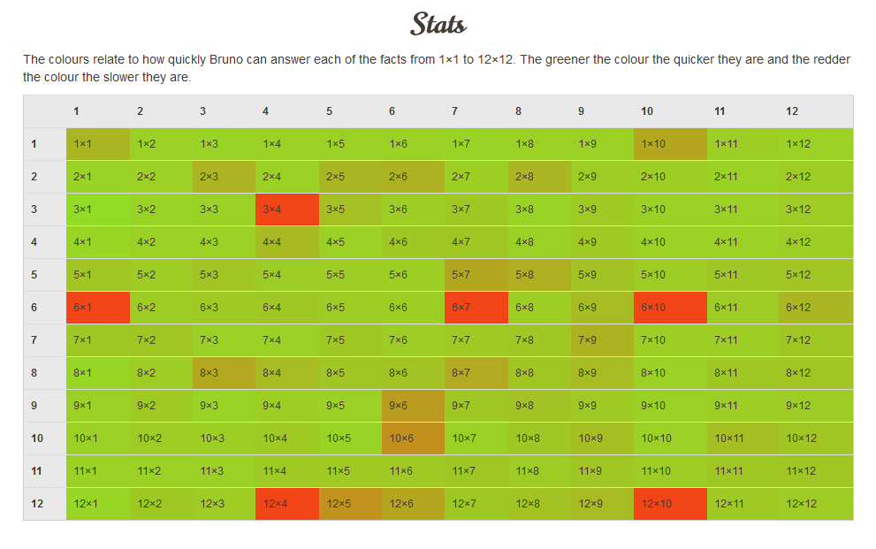
If you have any questions please do not hesitate to contact your class teachers.

Yours sincerely,
Kirsty Harrold
Maths lead

